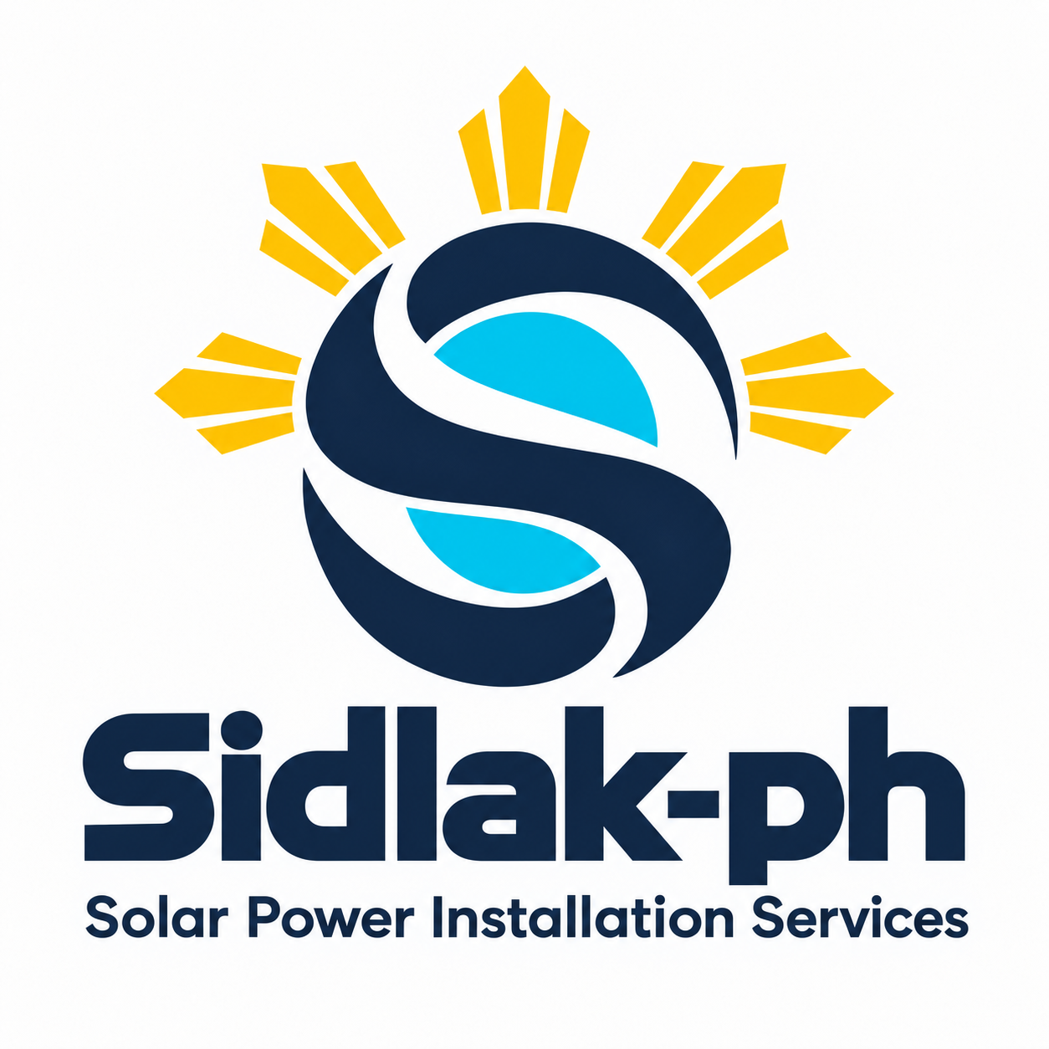

Sidlak-ph Company Profile
Solar Power Installation Services
DTI Business Name Registration No. 8532589

Who We Are
Sidlak-ph Solar Power Installation Services is a team of licensed electricians and solar installers united by a shared purpose: helping households take greater control of their energy needs through solar power. We bring electrical knowledge and installation skills together to help families make practical choices for their homes and their future.

Our Vision
A future where every Filipino household has the opportunity to achieve greater energy independence, and where communities thrive in homes powered by cleaner energy.

Our Mission
To help communities adopt solar power through responsible installation, clear guidance, and solutions suited to each household’s needs. We aim to support dependable energy for everyday living while contributing to efforts to reduce emissions and address climate change.

What We Offer
Our work focuses on residential solar installation, supported by site assessment and discussion of household energy needs. We offer labor-only installation or materials and installation packages, with the project scope agreed with each client.

Our Commitments
We put safety, careful workmanship, and honest communication at the heart of our work. We seek to help homeowners understand their system, its capabilities, and its limits. Our goal is to build lasting trust by recommending practical solutions that consider present needs and future plans.

Our Purpose in the Community
Every home that embraces solar is a step toward a more energy-independent Philippines. Through Sidlak-ph, we want to help families participate in a cleaner energy future and build stronger communities, one household at a time.
Powering homes. Empowering communities.
Message Sidlak-ph to discuss your home’s solar needs and arrange a site assessment.

